**Optional book for the course**

<http://www.barnesandnoble.com/w/beginning-c-programming-with-xna-game-studio-at-chamillard/1108649142?ean=2940014046589&isbn=2940014046589&itm=19&usri=xna>

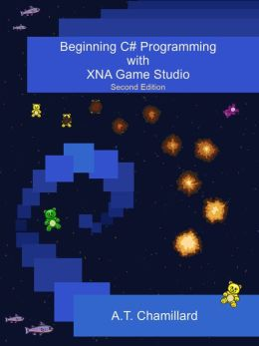

**Code**  
  
This section contains the code to accompany each of the chapters. You can download the first file to get the code all at once or you can download the code for each chapter separately

<http://www.burningteddy.com/Books/XNA/Default.aspx>